Java - RMI
Remote Method Invocation (RMI) facilitates object function calls between Java Virtual Machines (JVMs). JVMs can be located on separate computers - yet one JVM can invoke methods belonging to an object stored in another JVM. Methods can even pass objects that a foreign virtual machine has never encountered before, allowing dynamic loading of new classes as required.

The design goal for the RMI architecture was to create a Java distributed object model that integrates naturally into the Java programming language and the local object model.

RMI Architecture
The RMI architecture is based on one important principle: the definition of behavior and the implementation of that behavior are separate concepts. RMI allows the code that defines the behavior and the code that implements the behavior to remain separate and to run on separate JVMs.

This fits nicely with the needs of a distributed system where clients are concerned about the definition of a service and servers are focused on providing the service.

Specifically, in RMI, the definition of a remote service is coded using a Java interface. The implementation of the remote service is coded in a class. Therefore, the key to understanding RMI is to remember that interfaces define behavior and classes define implementation.

While the following diagram illustrates this separation,

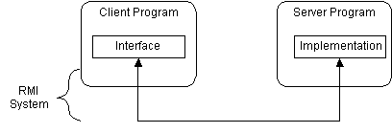

RMI supports two classes that implement the same interface. The first class is the implementation of the behavior, and it runs on the server. The second class acts as a proxy for the remote service and it runs on the client. This is shown in the following diagram.
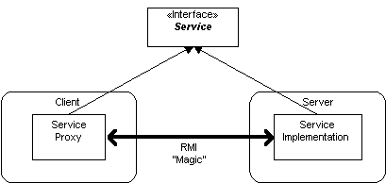
A client program makes method calls on the proxy object, RMI sends the request to the remote JVM, and forwards it to the implementation. Any return values provided by the implementation are sent back to the proxy and then to the client's program.

RMI Architecture Layers
The RMI implementation is essentially built from three abstraction layers. The first is the Stub and Skeleton layer, which lies just beneath the view of the developer. This layer intercepts method calls made by the client to the interface reference variable and redirects these calls to a remote RMI service.
The next layer is the Remote Reference Layer. This layer understands how to interpret and manage references made from clients to the remote service objects. In JDK 1.1, this layer connects clients to remote service objects that are running and exported on a server. The connection is a one-to-one (unicast) link. In the Java 2 SDK, this layer was enhanced to support the activation of dormant remote service objects via Remote Object Activation.
The transport layer is based on TCP/IP connections between machines in a network. It provides basic connectivity, as well as some firewall penetration strategies.
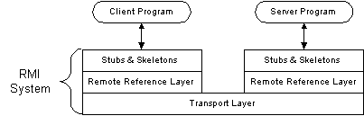
By using a layered architecture each of the layers could be enhanced or replaced without affecting the rest of the system. For example, the transport layer could be replaced by a UDP/IP layer without affecting the upper layers.

Using RMI
A working RMI system is composed of following parts.
- Interface definitions for the remote services
- Implementations of the remote services
- Stub and Skeleton files
- A server to host the remote services
- An RMI Naming service that allows clients to find the remote services
- A class file provider (an HTTP or FTP server)
- A client program that needs the remote services

Steps to Create RMI Application
- Define an interface for the Remote Classes.
- Implement the interface in a Server-side Application.
- Bind Objects to Registry Service.
- Create Stubs and Skeletons classes.
- Create and compile the client program to access the Remote Objects.
- Install files on the client and server machines.
- Start the RMI registry.

